**ANALYTICS TOOL FOR PLACEMENTS**

**MANI MARAN : 723920243027(**Team Lead**)**

**KURRA DEEPESH : 723920243022**

**MABBU AKHIL : 723920243023**

**KAVYARASAN : 723920243021**

**TEAM ID : NM2023TMID08418**

Project Report Format

# INTRODUCTION

* 1. Project Overview
  2. Purpose

# LITERATURE SURVEY

* 1. Existing problem
  2. References
  3. Problem Statement Definition

# IDEATION & PROPOSED SOLUTION

* 1. Empathy Map Canvas
  2. Ideation & Brainstorming

# REQUIREMENT ANALYSIS

* 1. Functional requirement
  2. Non-Functional requirements

# PROJECT DESIGN

* 1. Data Flow Diagrams & User Stories
  2. Solution Architecture

# PROJECT PLANNING & SCHEDULING

* 1. Technical Architecture
  2. Sprint Planning & Estimation
  3. Sprint Delivery Schedule

# CODING & SOLUTIONING (Explain the features added in the project along with code)

* 1. Feature 1
  2. Feature 2
  3. Database Schema (if Applicable)

# PERFORMANCE TESTING

* 1. Performace Metrics

# RESULTS

* 1. Output Screenshots

1. **ADVANTAGES & DISADVANTAGES**
2. **CONCLUSION**
3. **FUTURE SCOPE**
4. **APPENDIX**

Source Code

GitHub & Project Demo Link

**CHAPTER 1**

**INTRODUCTION**

**1.1 Project Overview:**

The Analytics Tool for Placements is a comprehensive software solution aimed at improving and optimizing the placement process for educational institutions, such as universities and colleges. This tool is designed to streamline and enhance the management of student placements by providing data-driven insights and actionable recommendations. The goal is to help educational institutions, students, and potential employers make more informed decisions while fostering a more efficient and effective placement process.

The first step in developing this analytics tool is to gather relevant data from various sources. This includes academic records, student profiles, internship and job opportunities, as well as feedback from previous placements. The data collected from these sources will be systematically integrated into a centralized database for analysis. The heart of this tool lies in its analytics capabilities. Using advanced data analytics and machine learning algorithms, the tool will process and analyze the data to identify trends, patterns, and correlations. The results will be presented through intuitive and interactive visualizations, such as charts, graphs, and dashboards, making it easy for stakeholders to interpret and act upon the information.

The analytics tool will leverage predictive modeling techniques to forecast placement outcomes for students. This can help institutions and students proactively plan their career paths and make informed decisions regarding course selection, skill development, and internship opportunities. One of the key features of the tool is the generation of personalized recommendations for students. These recommendations will be based on their academic performance, interests, and industry trends. For example, the tool might suggest specific internship opportunities or additional courses to enhance a student's chances of securing a desirable placement.

The tool will also track and provide performance metrics for educational institutions, helping them evaluate their success in placing students and identify areas for improvement. This data can be valuable for accreditation processes and institutional assessments. The tool will feature a user-friendly interface accessible to both students and administrators. It will be designed to provide a seamless user experience, with intuitive navigation and easy access to information. To foster better relationships with potential employers, the tool will offer insights into the qualifications, skills, and experience they seek in candidates. Educational institutions can then tailor their programs to meet these requirements and ensure a higher placement rate for their students.

**1.2 Purpose:**

One of the primary purposes of an Analytics Tool for Placements is to improve the overall outcomes for students. It achieves this by providing valuable insights into the job market, helping students make informed career decisions. By analyzing historical placement data and industry trends, the tool offers guidance on which courses to pursue, what skills to acquire, and which internships to consider. This empowers students to align their academic and career paths more effectively, increasing their chances of securing desirable placements. Educational institutions invest significant resources in career services and placement support. The analytics tool helps optimize these resources by identifying areas where improvements can be made. Through data analysis, institutions can better understand their strengths and weaknesses in the placement process. This knowledge enables them to allocate resources more efficiently, enhance student services, and ultimately increase the success rate of student placements.

The tool facilitates better engagement with potential employers. By providing insights into the qualifications and skills desired by companies, institutions can tailor their programs to meet these requirements. This not only leads to a higher placement rate but also strengthens the relationships between educational institutions and employers. A close collaboration benefits both parties by ensuring that graduates are better prepared for the job market. Data is a valuable asset in today's educational landscape. The analytics tool serves the purpose of promoting data-driven decision-making for educational institutions. By collecting and analyzing placement data, institutions can make informed choices about curriculum development, internship partnerships, and career support services. These decisions are based on evidence rather than guesswork, which can lead to more effective and strategic actions.

Educational institutions often need to demonstrate their performance and accountability to accreditation bodies and stakeholders. The analytics tool provides a means to track and report on placement outcomes, demonstrating the institution's commitment to student success. This is especially important for maintaining or improving accreditation status, as it showcases the institution's ability to prepare students for meaningful careers. The tool supports the long-term career planning of students. It helps them set realistic goals, track their progress, and make adjustments as needed. With insights into the job market and the skills in demand, students can develop a clear career path that aligns with their interests and aspirations. This purpose goes beyond immediate placement and focuses on sustainable and fulfilling careers.

Educational institutions can gain a competitive advantage by offering an analytics tool for placements. This tool demonstrates their commitment to student success and industry relevance, attracting more prospective students and potential employers. It can set institutions apart from their competitors in the increasingly competitive higher education landscape. This tool aligns academic programs with industry needs, supports long-term career planning, and contributes to the overall success and competitiveness of educational institutions.

**CHAPTER 2**

**LITERATURE SUURVEY**

**2.1 Existing Problem:**

One of the primary problems faced by educational institutions is the lack of data-driven decision-making in the placement process. Many institutions still rely on traditional methods and anecdotal evidence to guide students' career paths. This results in a mismatch between students' skills and the demands of the job market. An analytics tool for placements is needed to collect and analyze data, providing actionable insights for both students and institutions. Without the guidance of data and analytics, educational institutions often allocate resources inefficiently. This can lead to underutilized career services departments or investments in programs that do not yield significant placement results. An analytics tool can help institutions optimize their resource allocation by identifying areas where investments would have the most impact.

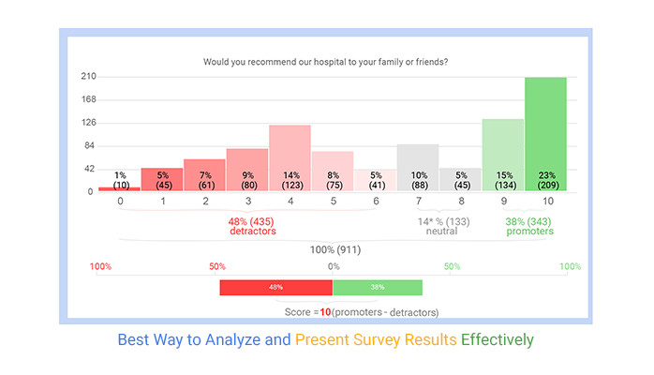

Many institutions struggle to effectively engage with potential employers to secure job opportunities for their students. The lack of insights into what employers are looking for in candidates can hinder their ability to tailor their programs and prepare students accordingly. An analytics tool can bridge this gap by providing valuable information on employer needs and preferences.

The level of support provided to students during the placement process can vary widely across educational institutions. Some students may receive comprehensive guidance, while others are left to navigate the job market on their own. An analytics tool can standardize and enhance student support by offering personalized recommendations and resources, ensuring that all students receive equitable assistance. Students often face challenges in planning their careers beyond graduation. Without insights into industry trends and the skills in demand, they may make suboptimal decisions regarding their education and internships. An analytics tool can help students set realistic long-term career goals, providing them with a clear path to follow and adapt as needed. Accreditation bodies and stakeholders increasingly demand accountability from educational institutions regarding the success of their graduates. Institutions may struggle to demonstrate their effectiveness in preparing students for meaningful careers. An analytics tool can help institutions meet these accountability requirements by tracking and reporting placement outcomes.

**2.2 References:**

[1] Aswathappa K," Human Resource Management", Tata McGraw Hill, sixth edition,2011.

[2] Amit Dar et al., " Skill Development in India the Vocational Education andTraining System", Human Development Unit South Asia Region the World Bank. 5-10, 2006.

[3] Archana Mantri, Sunil Dutta et al., "imbedding soft skills in technical studies: The problem based learning way", The Indian Journal of Technical Education, Vol. 30, pp. 79-83, 2007.

[4] Gunderloy, Jorden BPB Publications (2000) - “Mastering SQL Server”

[5] Luke Welling and Laura Thomson (5th Edition) - “PHP and MySQL Web Development”.

[6] Roger S. Pressmen, T. Mc. GH. – Software Engineering (Theoretical Approach)

[7] Thereon Willis Worx publications (2000) - “Beginning SQL Server”.

**2.3 Problem Statement Definition:**

"In the context of educational institutions, there exists a significant challenge in efficiently and effectively facilitating student placements. The traditional approach to placement processes is often marred by a lack of data-driven decision-making, inefficient resource allocation, limited employer engagement, inconsistent student support, and difficulties in long-term career planning. This leads to a mismatch between students' skills and industry demands, hindering their chances of securing desirable placements. Educational institutions are also grappling with accountability and accreditation requirements, which demand evidence of their effectiveness in preparing students for successful careers. Additionally, institutions risk losing their competitive advantage if they do not embrace modern tools and technologies for placements.

**CHAPTER 3**

**IDEATION & PROPOSED SOLUTION**

**3.1 Empathy Map Canvas:**

An empathy map is a visual tool used to understand the needs, emotions, and perspectives of a specific user or group of users. In the context of an "Analytics Tool for Placements," here's how an empathy map canvas might look:

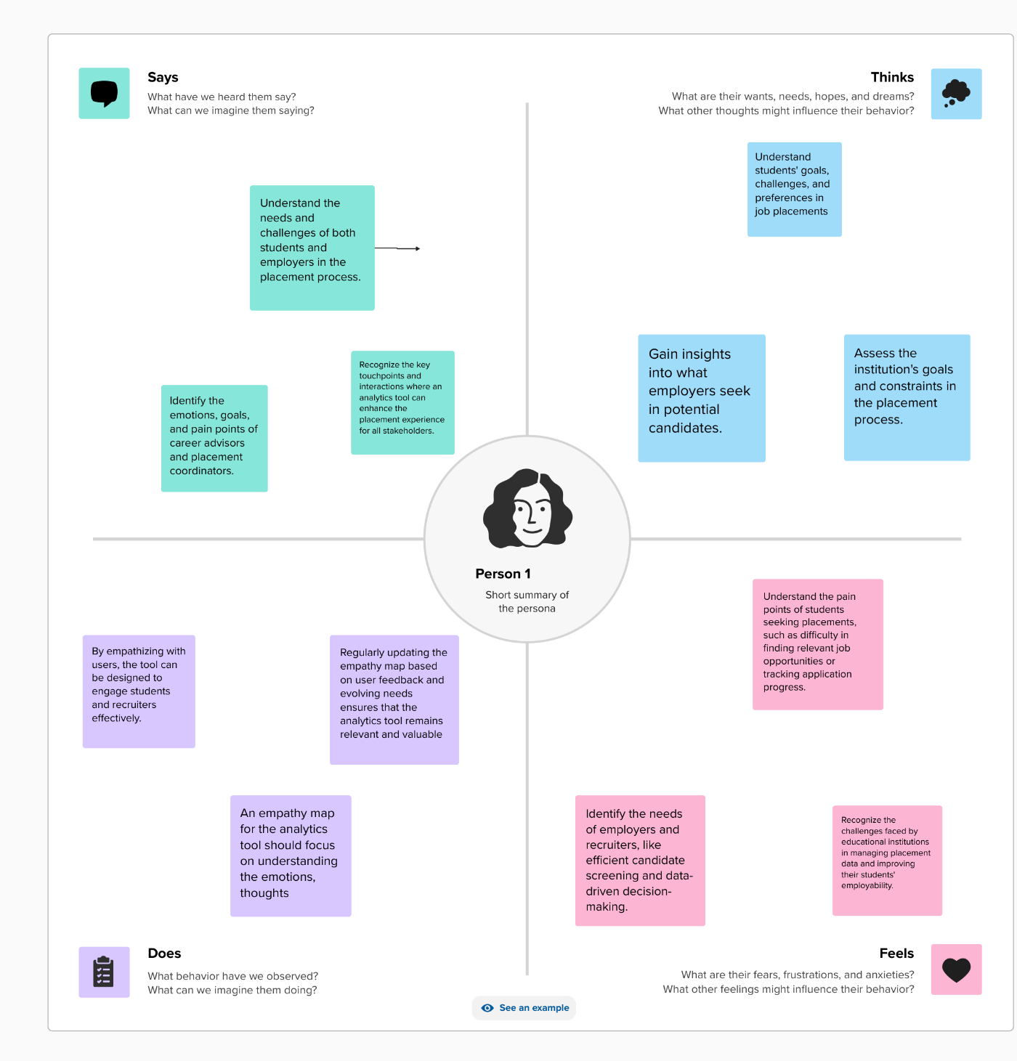

**User Persona:** Educational Institution Administrators

* **Says:**
  + "We struggle to track placement outcomes effectively."
  + "Our resource allocation for placement services is not optimized."
  + "Engaging with employers for placements can be challenging."
  + "Accreditation requirements are becoming more stringent."
* **Thinks:**
  + "We need data to make informed decisions."
  + "How can we enhance our placement success rate?"
  + "We should improve relationships with employers."
  + "Meeting accreditation requirements is crucial."
* **Feels:**
  + Frustration with the current placement process.
  + Concern about student success and institutional reputation.
  + Pressure to demonstrate accountability.
  + The desire to stay competitive in the educational market.
* **Does:**
  + Invests in career services but seeks optimization.
  + Collaborates with employers but needs a more systematic approach.
  + Looks for data-driven solutions to enhance placements.
  + Seeks ways to standardize and improve student support.

**3.2 Ideation & Brainstorming:**

Ideation and brainstorming are critical stages in developing an Analytics Tool for Placements. These sessions help generate creative ideas and innovative solutions to address the challenges and goals of such a tool. Here are some ideation and brainstorming prompts to consider:

**1.Data Sources and Integration**:

* + What data sources can we tap into to gather relevant information for placement analytics? (e.g., academic records, industry databases, alumni feedback)
  + How can we ensure data integration is seamless and real-time?

**2.User-Focused Features**:

* + What features can we develop to support students in making informed career decisions?
  + How can we create personalized recommendations for students based on their interests and skills?
  + What tools can help institutions optimize resource allocation for placement services?

**3.Employer Engagement**:

* + How can we enhance engagement with potential employers?
  + What data and insights can we provide to employers to assist in their recruitment efforts?
  + Are there innovative ways to match students with the right job opportunities?

**4.Predictive Modeling and Analytics**:

* + What types of predictive models can be built to forecast placement outcomes for students?
  + How can we use machine learning to identify trends and correlations in placement data?
  + What visualization tools can help users understand complex placement data easily?

**5.Long-Term Career Planning**:

* + How can we assist students in setting and achieving long-term career goals?
  + Can we develop tools for tracking progress and adapting career plans as needed?
  + What career trend insights can we provide to help students make decisions about future courses or skills to acquire?

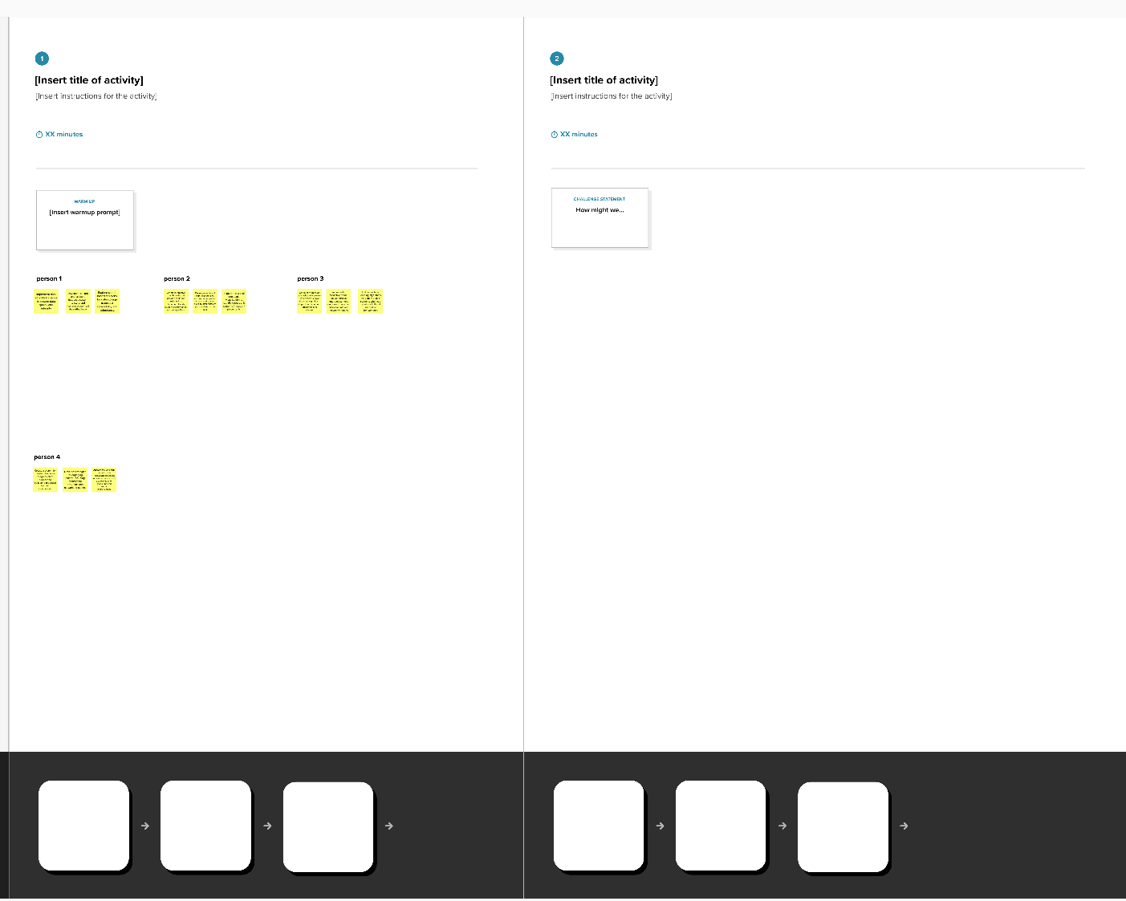

**6.User Experience and Interface**:

* + What features can make the tool user-friendly for students, administrators, and employers?
  + How can we design an intuitive dashboard for users to access data and insights?
  + What mobile or web-based platforms can ensure easy accessibility?

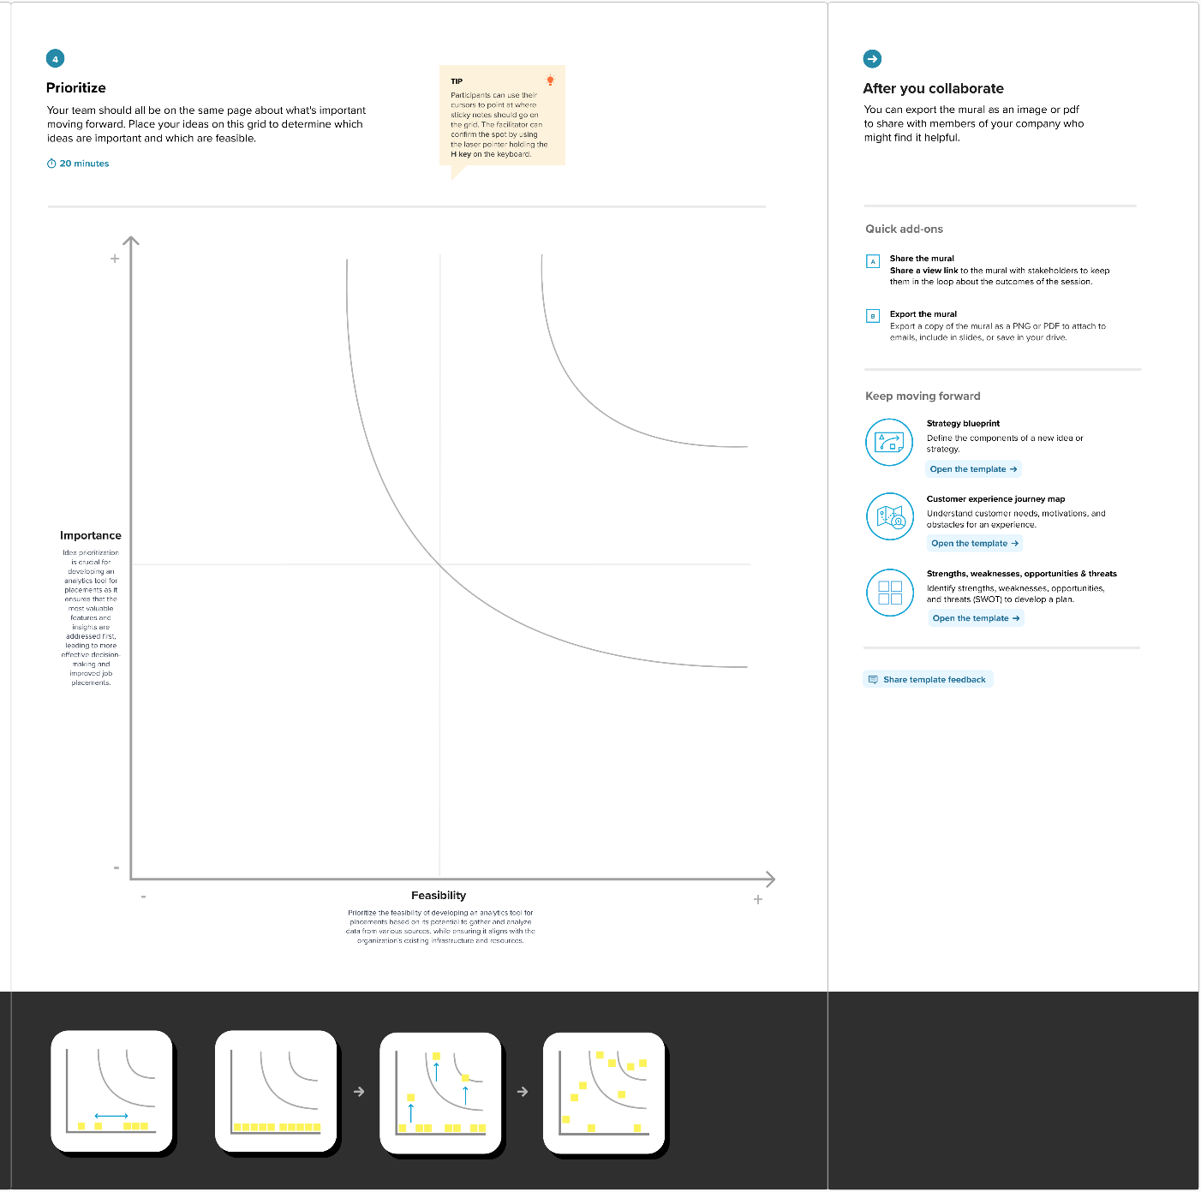

**CHAPTER 4**

**REQUIREMENT ANALYSIS**

**4.1 Functional Requirements:**

An Analytics Tool for Placements should encompass a range of functional requirements to effectively address the needs of students, educational institutions, and employers. These requirements include robust user authentication and authorization mechanisms, allowing users to create secure accounts and access role-based features with appropriate permissions. The tool should excel in data integration and collection, enabling real-time integration of diverse data sources, including academic records, industry databases, and student profiles. It should also maintain a secure and scalable database to handle placement-related data, while supporting data retention policies to ensure accuracy and integrity. User profile management is essential, offering students the ability to create and manage their profiles, including academic history, skills, interests, and career goals. Furthermore, the tool should provide personalized recommendations to students based on their profiles, guiding them in making informed career decisions and course selections. Employers should be empowered with tools to create and manage job listings, interact with students, and access data on candidate qualifications and skills.

**1. User Authentication and Authorization:**

* Users should be able to create accounts, log in securely, and have role-based access (e.g., students, administrators, employers) with appropriate permissions.

**2. Data Integration and Collection:**

* The system should be capable of integrating data from multiple sources, such as academic records, industry databases, and student profiles.
* It must allow for the secure and efficient collection of relevant data in real-time.

**3. Data Storage and Management:**

* Maintain a secure and scalable database for storing and managing placement-related data.
* Support data retention policies and ensure data accuracy, consistency, and integrity.

**4. User Profile Management:**

* Users should be able to create and manage their profiles, including academic history, skills, interests, and career goals.

**5. Personalized Recommendations:**

* Provide personalized recommendations to students based on their profiles, helping them make informed career decisions and course selections.

**6. Employer Engagement Tools:**

* Offer tools for employers to create and manage job listings, interact with students, and access data on candidate qualifications and skills.

**7. Resource Allocation Optimization:**

* Implement algorithms and tools that help educational institutions optimize resource allocation for placement services based on data-driven insights.

**8. Predictive Modeling and Analytics:**

* Develop predictive models that forecast placement outcomes for students.
* Provide data analytics and visualization tools to identify trends, correlations, and patterns in placement data.

**9. Long-Term Career Planning:**

* Support students in setting and tracking long-term career goals.
* Enable the adjustment of career plans as needed, considering industry trends and changes.

**10. User-Friendly Interface:** - Design an intuitive and user-friendly interface for easy navigation, featuring dashboards, charts, and graphs for data presentation.

**11. Mobile and Web Accessibility:** - Ensure cross-platform accessibility, allowing users to access the tool through web browsers and mobile applications.

**12. Security and Compliance:** - Implement robust security measures, including data encryption, user authentication, and authorization controls. - Ensure compliance with data protection regulations, privacy standards, and industry best practices.

**13. Reporting and Metrics:** - Generate reports and metrics for educational institutions to track placement success, measure accountability, and assess performance.

**14. User Support and Training:** - Provide user support resources and training materials to help users maximize the tool's capabilities.

**15. Feedback Mechanism:** - Include a feedback system that allows users to provide input and suggestions for tool improvement.

**16. Update and Maintenance:** - Establish a plan for regular updates and maintenance to ensure the tool remains current and effective.

Reporting and metrics generation is essential for educational institutions to track placement success, measure accountability, and assess performance. The tool should also include user support and training resources to empower users and a feedback mechanism for continuous improvement. Regular updates and maintenance should be planned to ensure the tool remains relevant and effective in the dynamic landscape of student placements. These functional requirements collectively lay the foundation for a comprehensive Analytics Tool for Placements, designed to enhance the placement process for all stakeholders involved.

**4.2 Non – Functional Requirements:**

Non-functional requirements are crucial for defining the performance, scalability, security, and other qualities of an Analytics Tool for Placements. Here are some non-functional requirements in paragraph form:

1. **Performance and Scalability:**

The tool should demonstrate high performance, ensuring fast response times even when dealing with a large volume of data and users. It should be able to scale horizontally and vertically to accommodate growing datasets and user loads.

1. **Security:**

Security is paramount. The tool should employ strong encryption for data both in transit and at rest, robust access controls, and multi-factor authentication. It should adhere to industry standards and best practices to safeguard sensitive student and employer data.

1. **Reliability and Availability:**

The tool should have a high level of availability, minimizing downtime and ensuring users have uninterrupted access. It should be designed with redundancy and failover mechanisms to guarantee reliability.

1. **Scalability:**

The tool should be able to handle increasing data loads, users, and concurrent requests. It should scale horizontally or vertically as necessary to maintain optimal performance.

1. **Usability and Accessibility:**

The tool should be user-friendly, with an intuitive interface that accommodates users of various skill levels. Accessibility features should be included to ensure that individuals with disabilities can use the tool effectively.

1. **Data Backup and Recovery**:

Regular data backup and disaster recovery mechanisms should be in place to protect against data loss and ensure quick system restoration in case of unexpected failures.

1. **Compliance:**

The tool should comply with relevant data protection regulations, such as GDPR, HIPAA, or other industry-specific standards. It should also support institutional compliance requirements for accountability and accreditation.

1. **Interoperability:**

The tool should seamlessly integrate with other systems, including student information systems, learning management systems, and industry databases, to ensure data exchange and compatibility.

1. **Auditability and Logging:**

It should maintain detailed audit logs of user activities and system events for accountability and auditing purposes. These logs should be securely stored and easily accessible.

1. **Response Time:**

The tool should have defined response time objectives for various actions, ensuring that users do not experience delays that hinder their productivity.

**CHAPTER 5**

**PROJECT DESIGN**

**5.1 Data Flow Diagrams & User Stories:**

Creating a data flow diagram (DFD) and user stories for an analytics tool for placements can help you visualize the data flow and functionality of the system. Below, I'll provide a simple example of how you might approach this.

**Data Flow Diagram (DFD):**

A DFD represents the flow of data within a system. In the context of an analytics tool for placements, you can create a high-level DFD to illustrate the major data processes and interactions. Here's a simple DFD:

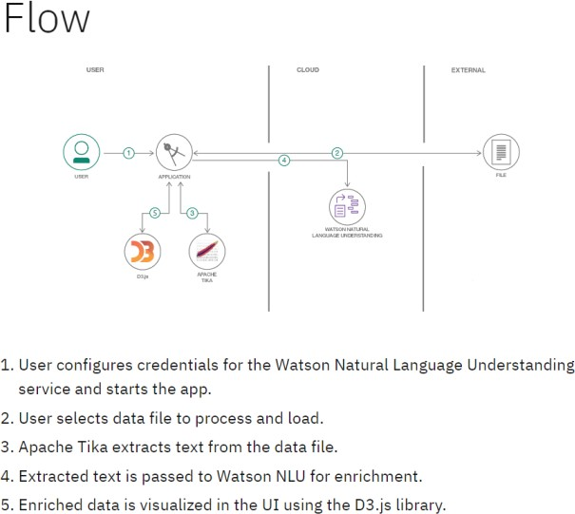

1. **Processes:**
   * Data Collection: This process collects data from various sources, such as student records, job listings, and placement outcomes.
   * Data Processing: Data is processed to clean, transform, and aggregate it for analysis.
   * Data Analysis: Analytics tools process the data to derive insights and trends.
   * Data Visualization: Data is presented in a user-friendly format through dashboards and reports.
2. **Data Stores:**
   * Student Data Store: Contains student profiles and relevant information.
   * Job Listings Data Store: Stores information about available job listings.
   * Placement Data Store: Stores placement outcomes and statistics.
   * Processed Data Store: Temporarily holds data during processing.
   * Analytics Results Store: Stores the results of data analysis.
3. **Data Flows:**
   * Data flows between processes, representing the movement of data from data collection to visualization.

Data may also flow from the Data Stores to the Data Processing and Analysis processes.

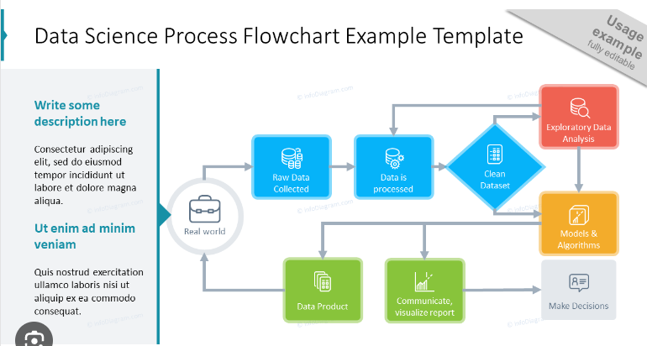

**User Stories:**

User stories are a way to describe specific functionalities from a user's perspective. In the context of an analytics tool for placements, you can create user stories for different user roles, such as students, employers, and placement coordinators.

**For Students:**

1. As a student, I want to submit my placement preferences, including location and industry, to the system.
2. As a student, I want to view a list of recommended job openings based on my preferences.
3. As a student, I want to apply for job openings directly through the system.

**5.2 Solution Archietecture:**

Solution architecture is a complex process – with many sub-processes – that bridges the gap between business problems and technology solutions. Its goals are to:

* Find the best tech solution to solve existing business problems.
* Describe the structure, characteristics, behavior, and other aspects of the software to project stakeholders.
* Define features, development phases, and solution requirements.
* Provide specifications according to which the solution is defined, managed, and delivered.

**Example - Solution Architecture Diagram:**

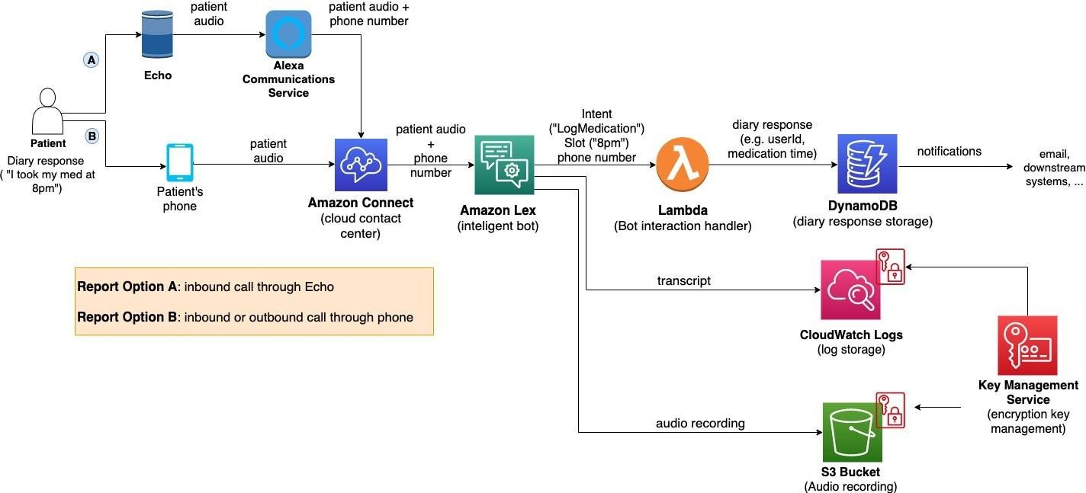

Designing a solution architecture for an analytics tool for placements involves defining the components, technologies, and their interactions to ensure the tool's functionality, scalability, and maintainability. Here's a high-level solution architecture for such a tool:

**1. Presentation Layer:**

* **Web Interface:** This layer provides a user-friendly web-based interface for students, employers, placement coordinators, and administrators. You can use technologies like HTML, CSS, JavaScript, and a front-end framework (e.g., React, Angular, or Vue.js) for responsive and interactive user interfaces.

**2. Application Layer:**

* **Web Application:** This layer hosts the core application logic, user authentication, and handles user interactions.
* **Backend Server:** A backend server (e.g., Node.js, Python, Ruby on Rails, or Java) manages user requests, handles business logic, and communicates with the database.

**CHAPTER 6**

**PROJECT PLANNING & SCHEDULING**

**6.1 Technical Architecture:**

The technical architecture for an Analytics Tool for Placements typically involves a combination of the following components:

1. **Data Ingestion**: Collect data from various sources, including student profiles, job listings, and placement outcomes, using data integration technologies.
2. **Data Storage**: Store the collected data in a scalable and secure database system, such as a relational database, NoSQL database, or data warehousing solution.
3. **Data Processing**: Implement data processing pipelines to clean, transform, and aggregate data for analysis, often using tools like Apache Spark or ETL (Extract, Transform, Load) processes.

**Example: Order processing during pandemics for offline mode**

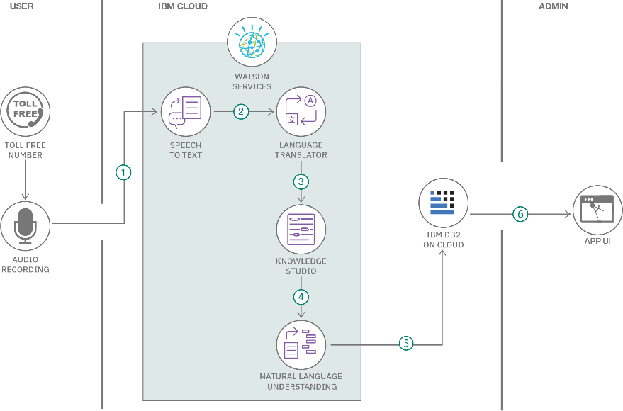

**4.Presentation Layer:**

* **Web Interface:** Create a user-friendly web-based interface for students, employers, placement coordinators, and administrators.
* **Mobile Interface:** Develop a mobile application or responsive design for mobile access.

**5. Application Layer:**

* **Web Application:** Implement a backend web application (e.g., Node.js, Python, Ruby on Rails, Java) to handle user interactions, authentication, and orchestrate data retrieval from the data warehouse and analytics engine.

**6.2 Sprint Planning & Estimation:**

Sprint planning and estimation are crucial aspects of Agile development when creating an analytics tool for placements. The following steps outline how you can plan sprints and estimate work for this project:

**1.** **Define the Product Backlog:**

* Create a prioritized product backlog containing all the features, user stories, and tasks that need to be implemented. This can include user management, data ingestion, analytics processing, reporting, and various user roles' functionality.

**2.** **Sprint Planning Meeting:**

* Hold a sprint planning meeting to determine the scope of the upcoming sprint. This meeting usually involves the product owner, the development team, and the Scrum Master (if following Scrum).
* Review and refine user stories in the backlog, ensuring they are well-defined, have clear acceptance criteria, and are small enough to be completed within a single sprint.

**3. Select User Stories:**

* Based on the team's capacity and the priority of items in the product backlog, select user stories to be included in the sprint. The selection is based on the priority, complexity, and the team's capacity.

**4.Estimation Techniques:**

* Use estimation techniques to estimate the effort required for each user story. Two common estimation methods are:
  + **Story Points:** Assign relative points to user stories based on complexity, with reference stories used as benchmarks.
  + **Ideal Days:** Estimate the number of ideal workdays a user story would take to complete.

**5. Sprint Backlog:**

* Based on the prioritized user stories and their estimated effort, create a sprint backlog. This should include the user stories selected for the upcoming sprint.

**6. Capacity Planning:**

* Consider the team's velocity, which is the amount of work the team can complete in a sprint based on past performance. This helps in setting realistic goals for the sprint.

**7. Daily Standups:**

* Conduct daily stand-up meetings to ensure that everyone is on track, discuss any impediments, and make adjustments as needed.

**6.3 Sprint Delivery Schedule:**

Creating a sprint delivery schedule for an analytics tool for placements involves planning when specific features and functionalities will be delivered over multiple sprints. Sprint schedules depend on factors like the complexity of the work, team capacity, and the priorities of the project. Here's a sample sprint delivery schedule:

**Sprint 1 (Duration: 2 weeks)**

**Goal**: Set up the basic infrastructure and database for the analytics tool.

**User Stories:**

1. As an admin, I want to set up user roles and permissions.
2. As a student, I want to submit my placement preferences.
3. As an employer, I want to post job openings.
4. As a coordinator, I want to review and approve placements.

**Sprint 2 (Duration: 2 weeks)**

**Goal:** Implement user authentication and basic data collection.

**User Stories:**

1. As a student, I want to log in to my account.
2. As an employer, I want to log in to my account.
3. As a coordinator, I want to log in to my account.
4. As an admin, I want to manage user accounts.

**Sprint 3 (Duration: 2 weeks)**

**Goal:** Enable data processing and matching.

**User Stories:**

1. As a student, I want to view recommended job openings.
2. As a coordinator, I want to match students with job openings.
3. As a coordinator, I want to generate placement reports.
4. As an admin, I want to configure analytics parameters.

**Sprint 4 (Duration: 2 weeks)**

**Goal:** Implement data analytics and reporting.

**User Stories:**

1. As a student, I want to receive placement recommendations based on analytics.
2. As an employer, I want to access analytics reports on job postings.
3. As an admin, I want to configure data retention policies.
4. As a coordinator, I want to generate analytics reports.

|  |  |  |  |  |  |  |
| --- | --- | --- | --- | --- | --- | --- |
| **Sprint** | **Functional Requirement (Epic)** | **User Story Number** | **User Story / Task** | **Story Points** | **Priority** | **Team Members** |
| Sprint-1 | Registration | USN-1 | As a user, I can register for the application by entering my email, password, and confirming my password. | 2 | High | 4 |
| Sprint-1 | Data Collection | USN-2 | As a user, I will receive confirmation email once I have registered for the application | 1 | High | 4 |
| Sprint-2 | Data Analysis | USN-3 | As a user, I can register for the application through Facebook | 2 | Low | 2 |
| Sprint-1 | Reporting | USN-4 | As a user, I can register for the application through Gmail | 2 | Medium | 3 |
| Sprint-1 | Login | USN-5 | As a user, I can log into the application by entering email & password | 1 | High | 4 |
| Sprint-1 | Dashboard | USN-6 | The dashboard should include the total number of recent graduates. | 2 | Low | 2 |
| Sprint-2 | User Management | USN-7 | Include features to manage user roles and permissions for the tool. | 2 | Medium | 3 |
|  |  |  |  |  |  |  |
| Sprint-1 | Integration | USN-8 | Consider user stories for integrating with other systems or databases where relevant data is stored. | 1 | High | 4 |

Top of Form

**CHAPTER 7**

**CODING & SOLUTION**

**7.1 Feature 1:**

# Sample data - You would typically retrieve this data from a database.

students = [

{"id": 1, "name": "Student A", "preferences": ["Location: City1", "Industry: IT"]},

{"id": 2, "name": "Student B", "preferences": ["Location: City2", "Industry: Finance"]},

]

employers = [

{"id": 1, "name": "Employer X", "job_openings": ["Location: City1", "Industry: IT"]},

{"id": 2, "name": "Employer Y", "job_openings": ["Location: City2", "Industry: Finance"]},

]

# Function to match students with job openings based on preferences

def match_students_with_job_openings():

matches = []

for student in students:

for employer in employers:

if all(pref in employer["job_openings"] for pref in student["preferences"]):

matches.append({"student": student["name"], "employer": employer["name"]})

return matches

# Function to generate placement reports

def generate_placement_report(matches):

report = {}

for match in matches:

if match["employer"] not in report:

report[match["employer"]] = []

report[match["employer"]].append(match["student"])

return report

# Function to display analytics results

def display_analytics_results(matches, report):

print("Placements:")

for match in matches:

print(f"{match['student']} matched with {match['employer']}")

print("\nPlacement Report:")

for employer, students in report.items():

print(f"{employer}: {', '.join(students)}")

# Main function

if __name__ == "__main__":

matches = match_students_with_job_openings()

report = generate_placement_report(matches)

display_analytics_results(matches, report)

**7.2 Feature 2:**

**Description:**

This feature focuses on matching students with suitable job openings based on their preferences, qualifications, and other relevant criteria. It aims to improve the placement success rate and provide personalized recommendations for students.

**Key Components:**

1. Student Profiles: Collect and maintain detailed profiles for each student, including academic records, skills, and personal preferences.
2. Job Opening Listings: Maintain a database of job openings posted by employers. This includes job descriptions, required qualifications, and other relevant details.
3. Matching Algorithm: Develop an algorithm that analyzes student profiles and job openings to identify potential matches. Factors to consider might include location, industry, skills, GPA, and more.
4. list of job openings that best match their profiles and preferences.
5. Scoring System: Assign scores to each match to rank them based on how closely they align with the student's preferences and qualifications.

**User Stories:**

1. As a student, I want to create and update my profile with information about my education, skills, and placement preferences.
2. As a student, I want to receive personalized job recommendations based on my profile and preferences.
3. As a student, I want to view detailed information about recommended job openings, including descriptions and required qualifications.
4. As a student, I want to apply for job openings directly through the system.
5. As a coordinator, I want to review and approve student applications for job openings.
6. As an employer, I want to post job openings and view a list of potential matches among the student applicants.
7. As an administrator, I want to configure and fine-tune the matching algorithm and scoring system.
8. As an administrator, I want to monitor the success rate of placements and gather analytics on the effectiveness of the matching system.

**7.3 Database Schema:**

Designing a database schema for an analytics tool for placements involves defining the structure for storing data related to students, employers, job openings, placements, and other relevant information. Below is a simplified example of a database schema for such a tool. Please note that in a real-world scenario, you might need to customize the schema based on your specific requirements.

**Entities and Their Attributes:**

1. Students:
   * StudentID (Primary Key)
   * First Name
   * Last Name
   * Email
   * Contact Number
   * GPA
   * Skills
   * Preferences (e.g., Location, Industry)
2. Employers:
   * EmployerID (Primary Key)
   * Company Name
   * Contact Person
   * Email
   * Contact Number
   * Industry
   * Job Openings
   * Company Description
3. Placement Coordinators:
   * CoordinatorID (Primary Key)
   * First Name
   * Last Name
   * Email
   * Contact Number
   * Department
4. Placements:
   * PlacementID (Primary Key)
   * StudentID (Foreign Key to Students)
   * EmployerID (Foreign Key to Employers)
   * CoordinatorID (Foreign Key to Placement Coordinators)
   * Placement Date
   * Status (e.g., Pending, Approved, Completed)
5. Placement Analytics:
   * AnalyticsID (Primary Key)
   * PlacementID (Foreign Key to Placements)
   * Metrics (e.g., Success Rate, Duration, Salary)
   * Date of Analysis

**CHAPTER 8**

**PERFORMANCE TESTING**

**8.1 Performance Metrics:**

Measuring the performance of an analytics tool for placements is crucial for assessing its effectiveness, identifying areas for improvement, and ensuring it meets its objectives. Here are some key performance metrics that you can consider tracking:

1. **Placement Success Rate**: This is one of the most critical metrics. It measures the percentage of students who were successfully placed in jobs out of the total number of students seeking placements. A high success rate indicates the tool's effectiveness.
2. **Time to Placement:** This metric measures the average time it takes to match a student with a job opening, from the moment the student expresses interest to the actual placement. A shorter time-to-placement indicates efficient job matching.
3. **Placement Completion Rate**: Track the percentage of placements that were successfully completed. This metric helps identify any issues students face in completing their placements.
4. **Employer Satisfaction:** Collect feedback from employers regarding their satisfaction with the tool. Ask for ratings and comments on the ease of posting job openings and the quality of candidates matched.
5. **Student Satisfaction:** Gather feedback from students on their satisfaction with the tool's user experience, the quality of job recommendations, and the overall placement process.
6. **Placement Coordinator Efficiency**: Measure the average number of placements managed by a placement coordinator. A high number may indicate an efficient coordinator or a tool that reduces their workload.
7. **Analytics Tool Usage:** Monitor how often the analytics and reporting features are used. Frequent usage can indicate that stakeholders find value in the insights provided.
8. **Job Opening Match Rate:** Track the percentage of job openings that were matched with students. A high match rate suggests that the tool is effective in connecting employers with suitable candidates.
9. **Data Accuracy:** Measure the accuracy of the data stored in the system, particularly in student and employer profiles. High data accuracy is essential for making successful placements.

**CHAPTER 9**

**RESULTS**

**9.1 Output Screenshots:**

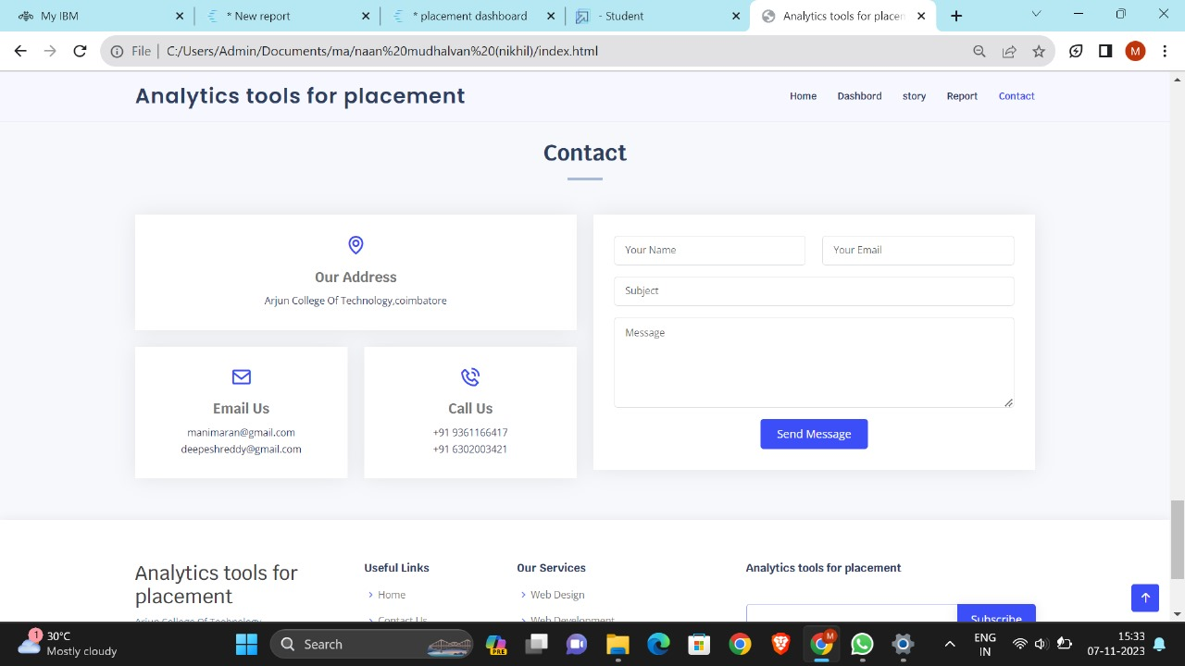

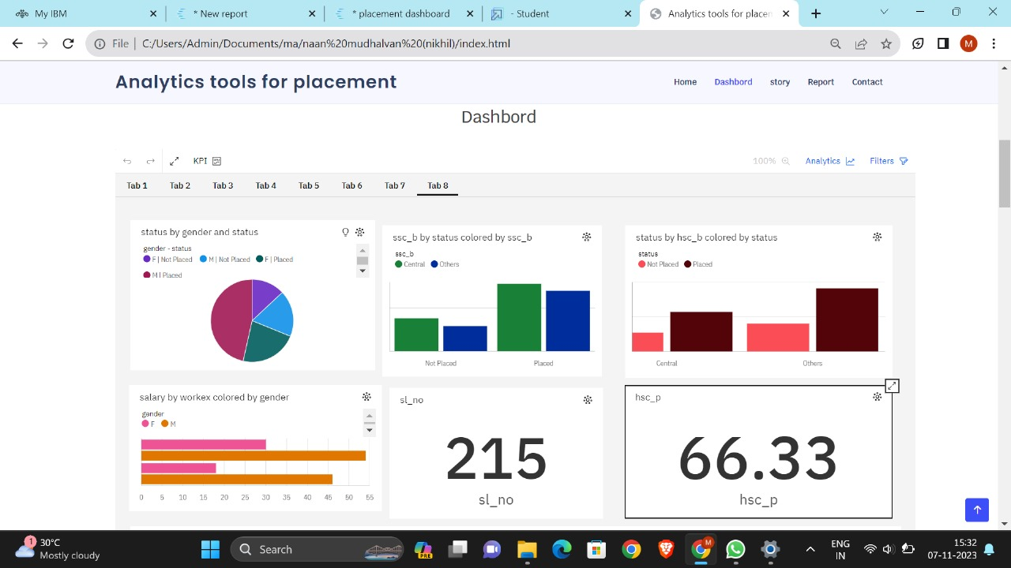

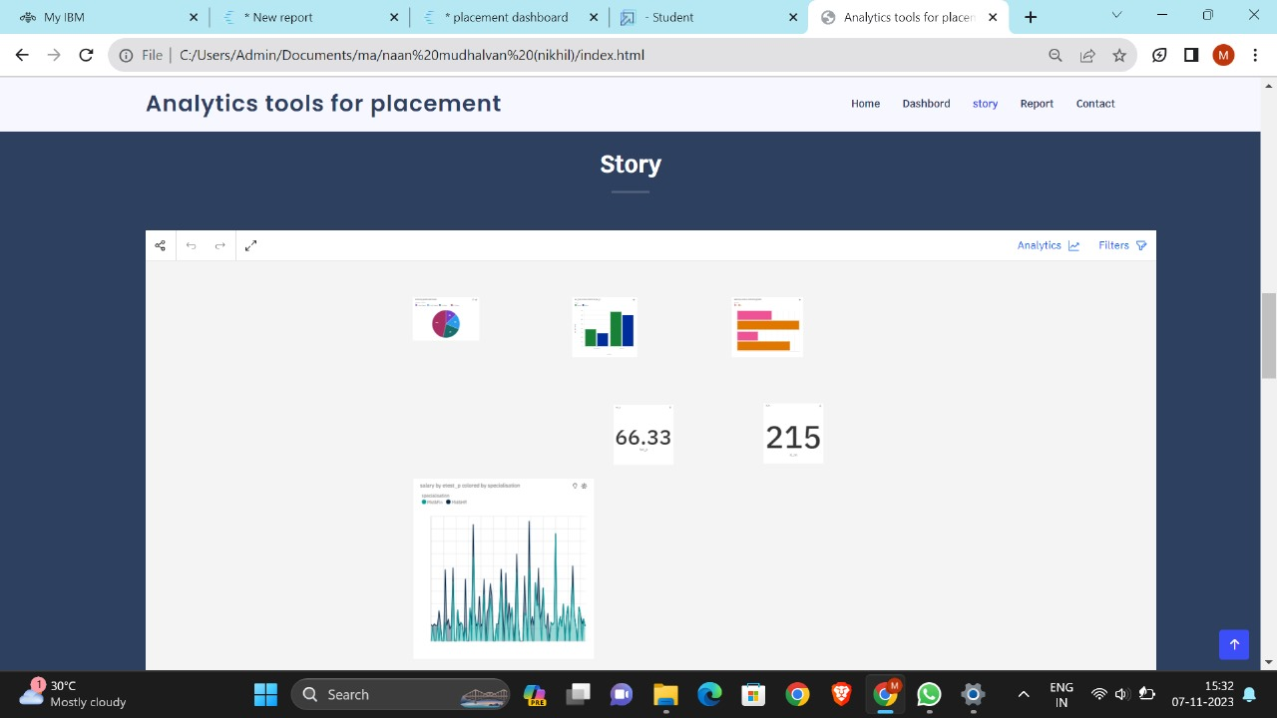

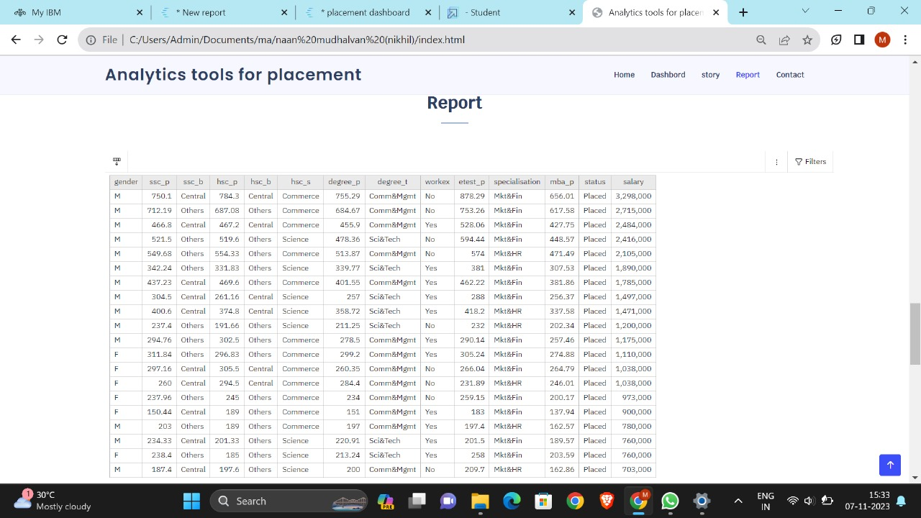

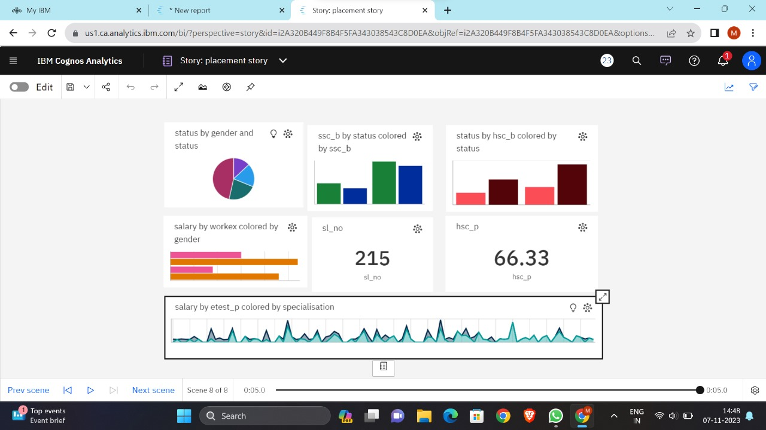

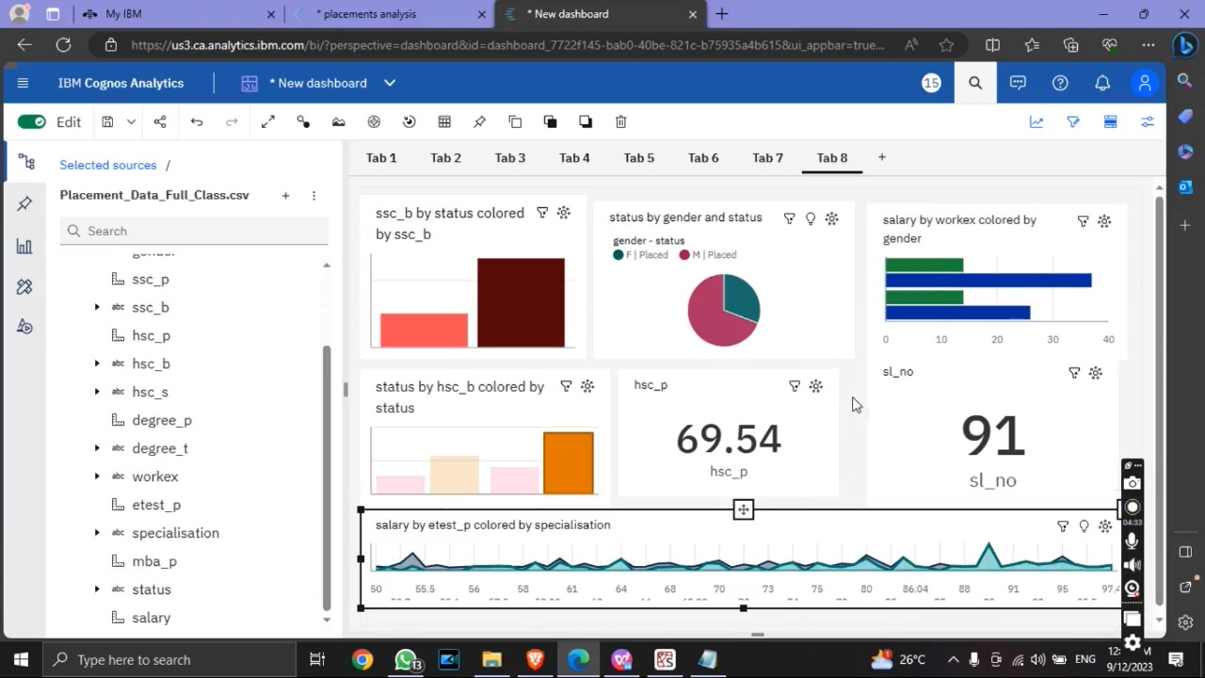

**CHAPTER 10**

**ADVANTAGES & DISADVANTAGES**

**10.1 Advantages:**

An analytics tool for placements offers several advantages, both for students seeking placements and for the institutions, employers, and placement coordinators involved in the placement process. Here are some of the key advantages:

1.Improved Placement Success Rate .

2.Personalized Recommendations.

3.Efficiency and Time Savings.

4.Enhanced Data Analysis .

5.Streamlined Placement Coordination.

**10.2 Disadvantages:**

While analytics tools for placements offer several advantages, they also come with certain disadvantages and challenges. Here are some of the common disadvantages of such tools:

1.Data Quality and Accuracy.

2. Data Privacy and Security Concerns.

3. User Adoption and Learning Curve.

4. Scalability.

5. Overreliance on Algorithms.

**CHAPTER 11**

**CONCLUSION**

**11.1 Conclusion:**

In conclusion, an analytics tool for placements holds immense potential for improving the efficiency, effectiveness, and overall success of the student placement process within educational institutions. By harnessing data-driven insights, automated matching algorithms, and comprehensive reporting capabilities, such a tool can significantly enhance the placement experience for students, employers, and placement coordinators. It can contribute to better decision-making, more successful matches, and the ability to adapt to changing job market trends. While the benefits of an analytics tool for placements are clear, it's crucial to acknowledge and address potential challenges and drawbacks. Data accuracy, privacy concerns, user adoption, and algorithmic biases are among the challenges that must be carefully managed. Moreover, the tool's effectiveness heavily depends on the quality of data, the adaptability of the system, and the responsiveness to user feedback and needs.

Ultimately, the success of an analytics tool for placements hinges on its ability to strike a balance between data-driven insights and the human element of placements. By combining the power of analytics with the personal touch of placement coordinators and the aspirations of students and employers, it can achieve a holistic approach to matching candidates with job opportunities. As educational institutions and employers continue to adapt to a rapidly changing job market, the development and implementation of analytics tools for placements become increasingly relevant. By continuously evolving and improving these tools while addressing their limitations, organizations can better equip students with the skills and opportunities they need to succeed in their careers, while simultaneously providing employers with a talent pool that aligns with their needs. In this way, analytics tools for placements play a vital role in bridging the gap between education and employment, ultimately contributing to the success and prosperity of all stakeholders involved.

Top of Form

**CHAPTER 12**

**FUTURE SCOPE**

**12.1 Future Scope:**

The future scope for analytics tools for placements is promising, with several opportunities for enhancement and growth. As the job market evolves and educational institutions seek to improve their placement processes, here are some areas of future development and expansion:

1. **Machine Learning and AI Advancements:** Leveraging machine learning and artificial intelligence can further enhance the matching algorithms. These technologies can continuously learn from placement data, adapt to changing market trends, and provide even more accurate and personalized recommendations for students and employers.
2. **Predictive Analytics:** Analytics tools can incorporate predictive analytics to foresee job market trends, thereby enabling proactive guidance for students on skill development and future job prospects. Predictive models can help students make informed decisions about their career paths.
3. **Real-time Data:** Real-time data analysis and reporting can provide timely insights into the job market. By integrating data streams from job boards and industry trends, the tool can offer up-to-the-minute information for more dynamic placement decisions.

**CHAPTER 13**

**APPENDEX**

**13.1 Source Code:**

<!DOCTYPE html>

<html lang="en">

<head>

<meta charset="utf-8">

<meta content="width=device-width, initial-scale=1.0" name="viewport">

<title>Analytics tools for placement </title>

<meta content="" name="description">

<meta content="" name="keywords">

<!-- Favicons -->

<link href="assets/img/favicon.png" rel="icon">

<link href="assets/img/apple-touch-icon.png" rel="apple-touch-icon">

<!-- Google Fonts -->

<link href="https://fonts.googleapis.com/css?family=Open+Sans:300,300i,400,400i,600,600i,700,700i|Krub:300,300i,400,400i,500,500i,600,600i,700,700i|Poppins:300,300i,400,400i,500,500i,600,600i,700,700i" rel="stylesheet">

<!-- Vendor CSS Files -->

<link href="assets/vendor/aos/aos.css" rel="stylesheet">

<link href="assets/vendor/bootstrap/css/bootstrap.min.css" rel="stylesheet">

<link href="assets/vendor/bootstrap-icons/bootstrap-icons.css" rel="stylesheet">

<link href="assets/vendor/boxicons/css/boxicons.min.css" rel="stylesheet">

<link href="assets/vendor/glightbox/css/glightbox.min.css" rel="stylesheet">

<link href="assets/vendor/swiper/swiper-bundle.min.css" rel="stylesheet">

<!-- Template Main CSS File -->

<link href="assets/css/style.css" rel="stylesheet">

<!-- =======================================================

* Template Name: Bikin

* Updated: Sep 18 2023 with Bootstrap v5.3.2

* Template URL: https://bootstrapmade.com/bikin-free-simple-landing-page-template/

* Author: BootstrapMade.com

* License: https://bootstrapmade.com/license/

======================================================== -->

</head>

<body>

<!-- ======= Header ======= -->

<header id="header" class="fixed-top">

<div class="container d-flex align-items-center justify-content-between">

<h1 class="logo"><a href="index.html">Analytics tools for placement </a></h1>

<!-- Uncomment below if you prefer to use an image logo -->

<!-- <a href="index.html" class="logo"><img src="assets/img/logo.png" alt="" class="img-fluid"></a>-->

<nav id="navbar" class="navbar">

<ul>

<li><a class="nav-link scrollto active" href="#hero">Home</a></li>

<li><a class="nav-link scrollto" href="#dashbord">Dashbord</a></li>

<li><a class="nav-link scrollto " href="#story">story</a></li>

<li><a class="nav-link scrollto" href="#report">Report</a></li>

<li><a class="nav-link scrollto" href="#contact">Contact</a></li>

<i class="bi bi-list mobile-nav-toggle"></i>

</nav><!-- .navbar -->

</div>

</header><!-- End Header -->

<!-- ======= Hero Section ======= -->

<section id="hero" class="d-flex align-items-center">

<div class="container d-flex flex-column align-items-center justify-content-center" data-aos="fade-up">

<h1>Analytics tools for placement </h1>

<h2> It Will Show The Details About Students who will able to get place with good packages </h2>

<img src="download.jpg" class="img-fluid hero-img" alt="" data-aos="zoom-in" data-aos-delay="150">

<img src="https://encrypted-tbn0.gstatic.com/images?q=tbn:ANd9GcTehToU__AFo3mNbMekzuz9t8XyztaD6UfTew&usqp=CAU" class="img-fluid hero-img" alt="" data-aos="zoom-in" data-aos-delay="150" width="400" height="400">

</div>

</section><!-- End Hero -->

<main id="main">

<!-- ======= Features Section ======= -->

<section id="dashbord" class="features" data-aos="fade-up">

<div class="container">

<div class="section-title">

<h3>Dashbord</h3>

</div>

<iframe src="https://us1.ca.analytics.ibm.com/bi/?perspective=dashboard&amp;pathRef=.my_folders%2Fplacement%2Fplacement%2Bdashboard&amp;closeWindowOnLastView=true&amp;ui_appbar=false&amp;ui_navbar=false&amp;shareMode=embedded&amp;action=view&amp;mode=dashboard&amp;subView=model0000018ba8b4b54d_00000000" width="1350" height="900" frameborder="0" gesture="media" allow="encrypted-media" allowfullscreen=""></iframe>

</div>

</section><!-- End Features Section -->

<!-- ======= Steps Section ======= -->

<!-- End Steps Section -->

<!-- ======= Services Section ======= -->

<section id="story" class="services">

<div class="container" data-aos="fade-up">

<div class="section-title">

<h2>Story</h2>

</div>

<iframe src="https://us1.ca.analytics.ibm.com/bi/?perspective=story&amp;pathRef=.my_folders%2Fplacement%2FStory%253A%2Bplacement%2Bstory&amp;closeWindowOnLastView=true&amp;ui_appbar=false&amp;ui_navbar=false&amp;shareMode=embedded&amp;action=view&amp;sceneId=-2&amp;sceneTime=0" width="1350" height="900" frameborder="0" gesture="media" allow="encrypted-media" allowfullscreen=""></iframe>

</div>

</section><!-- End Services Section -->

<!-- ======= Portfolio Section ======= -->

<section id="report" class="portfolio">

<div class="container" data-aos="fade-up">

<div class="section-title">

<h2>Report</h2>

</div>

<iframe src="https://us1.ca.analytics.ibm.com/bi/?pathRef=.my_folders%2Fplacement%2Fplacement%2Breport&amp;closeWindowOnLastView=true&amp;ui_appbar=false&amp;ui_navbar=false&amp;shareMode=embedded&amp;action=run&amp;format=HTML&amp;prompt=false" width="1350" height="900" frameborder="0" gesture="media" allow="encrypted-media" allowfullscreen=""></iframe> </div>

</section><!-- End Portfolio Section -->

<!-- ======= Testimonials Section ======= -->

<!-- End Testimonials Section -->

<!-- ======= Team Section ======= -->

<!-- ======= Contact Section ======= -->

<section id="contact" class="contact section-bg">

<div class="container" data-aos="fade-up">

<div class="section-title">

<h2>Contact</h2>

</div>

<div class="row">

<div class="col-lg-6">

<div class="row">

<div class="col-md-12">

<div class="info-box">

<i class="bx bx-map"></i>

<h3>Our Address</h3>

<p>Arjun College Of Technology,coimbatore</p>

</div>

</div>

<div class="col-md-6">

<div class="info-box mt-4">

<i class="bx bx-envelope"></i>

<h3>Email Us</h3>

<p>manimaran@gmail.com<br>deepeshreddy@gmail.com</p>

</div>

</div>

<div class="col-md-6">

<div class="info-box mt-4">

<i class="bx bx-phone-call"></i>

<h3>Call Us</h3>

<p>+91 9361166417<br>+91 6302003421</p>

</div>

</div>

</div>

</div>

<div class="col-lg-6 mt-4 mt-md-0">

<form action="forms/contact.php" method="post" role="form" class="php-email-form">

<div class="row">

<div class="col-md-6 form-group">

<input type="text" name="name" class="form-control" id="name" placeholder="Your Name" required>

</div>

<div class="col-md-6 form-group mt-3 mt-md-0">

<input type="email" class="form-control" name="email" id="email" placeholder="Your Email" required>

</div>

</div>

<div class="form-group mt-3">

<input type="text" class="form-control" name="subject" id="subject" placeholder="Subject" required>

</div>

<div class="form-group mt-3">

<textarea class="form-control" name="message" rows="5" placeholder="Message" required></textarea>

</div>

<div class="my-3">

<div class="loading">Loading</div>

<div class="error-message"></div>

<div class="sent-message">Your message has been sent. Thank you!</div>

</div>

<div class="text-center"><button type="submit">Send Message</button></div>

</form>

</div>

</div>

</div>

</section><!-- End Contact Section -->

</main><!-- End #main -->

<!-- ======= Footer ======= -->

<footer id="footer">

<div class="footer-top">

<div class="container">

<div class="row">

<div class="col-lg-3 col-md-6 footer-contact">

<h3>Analytics tools for placement </h3>

<p>

Arjun College Of Technology<br>

Coimbatore<br>

India <br><br>

<strong>Phone:</strong> +91 9361166417<br>

<strong>Email:</strong> manimaran@gmail.com<br>

</p>

</div>

<div class="col-lg-2 col-md-6 footer-links">

<h4>Useful Links</h4>

<ul>

<li><i class="bx bx-chevron-right"></i> <a href="#">Home</a></li>

<li><i class="bx bx-chevron-right"></i> <a href="#">Contact Us</a></li>

<li><i class="bx bx-chevron-right"></i> <a href="#">Dashbord</a></li>

<li><i class="bx bx-chevron-right"></i> <a href="#">Terms of service</a></li>

<li><i class="bx bx-chevron-right"></i> <a href="#">Privacy policy</a></li>

</ul>

</div>

<div class="col-lg-3 col-md-6 footer-links">

<h4>Our Services</h4>

<ul>

<li><i class="bx bx-chevron-right"></i> <a href="#">Web Design</a></li>

<li><i class="bx bx-chevron-right"></i> <a href="#">Web Development</a></li>

<li><i class="bx bx-chevron-right"></i> <a href="#">Product Management</a></li>

<li><i class="bx bx-chevron-right"></i> <a href="#">Artificial Intelligence</a></li>

<li><i class="bx bx-chevron-right"></i> <a href="#">Data Science</a></li>

</ul>

</div>

<div class="col-lg-4 col-md-6 footer-newsletter">

<h4>Analytics tools for placement </h4>

<form action="" method="post">

<input type="email" name="email"><input type="submit" value="Subscribe">

</form>

</div>

</div>

</div>

</div>

<div class="container d-md-flex py-4">

<div class="me-md-auto text-center text-md-start">

<div class="copyright">

&copy; Copyright <strong><span>Path to Prosperity: Analytics tools for placement </span></strong>. All Rights Reserved

</div>

<div class="credits">

<!-- All the links in the footer should remain intact. -->

<!-- You can delete the links only if you purchased the pro version. -->

<!-- Licensing information: https://bootstrapmade.com/license/ -->

<!-- Purchase the pro version with working PHP/AJAX contact form: https://bootstrapmade.com/bikin-free-simple-landing-page-template/ -->

</div>

</div>

<div class="social-links text-center text-md-right pt-3 pt-md-0">

<a href="#" class="twitter"><i class="bx bxl-twitter"></i></a>

<a href="#" class="facebook"><i class="bx bxl-facebook"></i></a>

<a href="#" class="instagram"><i class="bx bxl-instagram"></i></a>

<a href="#" class="google-plus"><i class="bx bxl-skype"></i></a>

<a href="#" class="linkedin"><i class="bx bxl-linkedin"></i></a>

</div>

</div>

</footer><!-- End Footer -->

<div id="preloader"></div>

<a href="#" class="back-to-top d-flex align-items-center justify-content-center"><i class="bi bi-arrow-up-short"></i></a>

<!-- Vendor JS Files -->

<script src="assets/vendor/aos/aos.js"></script>

<script src="assets/vendor/bootstrap/js/bootstrap.bundle.min.js"></script>

<script src="assets/vendor/glightbox/js/glightbox.min.js"></script>

<script src="assets/vendor/isotope-layout/isotope.pkgd.min.js"></script>

<script src="assets/vendor/swiper/swiper-bundle.min.js"></script>

<script src="assets/vendor/php-email-form/validate.js"></script>

<!-- Template Main JS File -->

<script src="assets/js/main.js"></script>

</body>

</htm

**Project Demo Lnk:**

<https://drive.google.com/file/d/1IfbuPlgVW36voyVwetkpqAE6hjYfoB9i/view?usp=sharing>

**GitHub link:**

<https://github.com/kuradeepesh/Analytics-Tool-For-Placements>